**Functional Specifications Document**

**For**

**Hardware Asset Tracking**

Prepared by

Steve Hirabayashi, Julien Laurent,

Christian Girala, Shoaib Khan, Carlos Baltodano, Bernice Templeman

**Team NULL Terminator**

3/26/2015

Table of Contents

# Summary………………………………………………………………………………3

Main Menu……………………………………………………………………………4-5

Inventory Status………………………………………………………………………5-6

Update Inventory……………………………………………………………………….6-7

Current List of Outstanding Issues……………………………………………………8-9

History of Borrowed/Reserved Items…………………………………………………9-10

Input Borrow Request………………………………………………………………11-15

Entering Borrower Contact Information………………………………………

Signature and Print Request……………………………………………………

Scanning and Saving Request Form (Borrow)……………………....................

Input Return Request……………………………………………………………….15-17

Searching Request Form………………………………………………………

Scanning and Saving Request Form (Return)…………………………………

View/Change EnTeC Class Reserved Amount………………………………………18-19

Summary

The Hardware Asset Tracker will assist the ENTEC Department of Miami-Dade College to easily follow through the tracking process of different hardware assets as well as help them keep records of these assets.

The different options available will consist of viewing current inventory status, update inventory, current issues, history of inventory borrows/reserves, inputting borrow requests which requires client information as well as a signature, deleting borrow requests, and view/change ENTEC class reserved amount.

Main Menu

Upon launching the program, it will display a menu for the user.

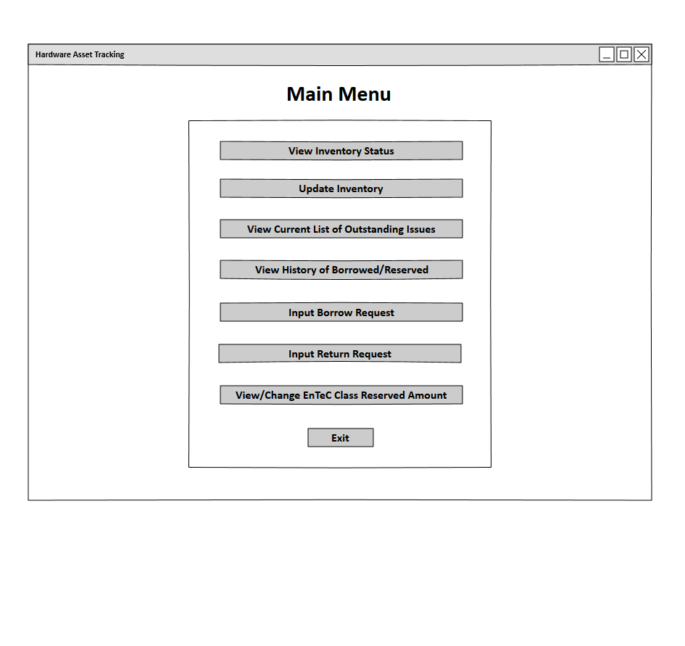

*Field/Data Elements*

|  |  |  |  |
| --- | --- | --- | --- |
| Field Name | Required | Field Type | Notes |
| View Inventory Status | - | Button | Displays Inventory Status Page |
| Update Inventory | - | Button | Displays Update Inventory Page |
| View Current List of Outstanding Issues | - | Button | Displays List of Outstanding Issues Page |
| View History of Borrowed/Reserved | - | Button | Displays History of Borrowed/Reserved Page |
| Input Borrow Request | - | Button | Displays Input Borrow Request Page |
| Input Return Request | - | Button | Displays Input Return Request Page |
| View/Change Entec Class Reserved Amount | - | Button | Displays View/Change Entec Class Reserved Amount Page |
| Exit | Yes | Button | Terminates Program |

Inventory Status

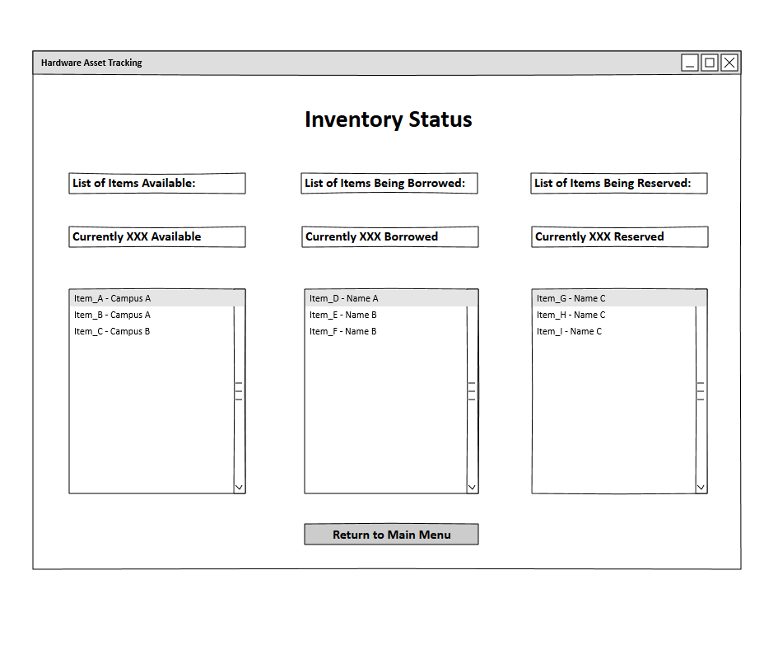

*Field/Data Elements*

|  |  |  |  |
| --- | --- | --- | --- |
| Field Name | Required | Field Type | Notes |
| Items Available | - | Scroll Box | Displays Campus where item is currently stored |
| Items Borrowed | - | Scroll Box | Displays Name of Borrower |
| Items Reserved | - | Scroll Box | Displays Name of Person who Reserved |
| Return to Main Menu | Yes | Button | User is redirected to Main Menu |

Selecting Inventory Status

* Inventory Status Page will display. This page shows all items that are currently available, borrowed, and reserved and by who.
* If the “Return to Main Menu” button is clicked, the Main Menu Page will display.

Update Inventory

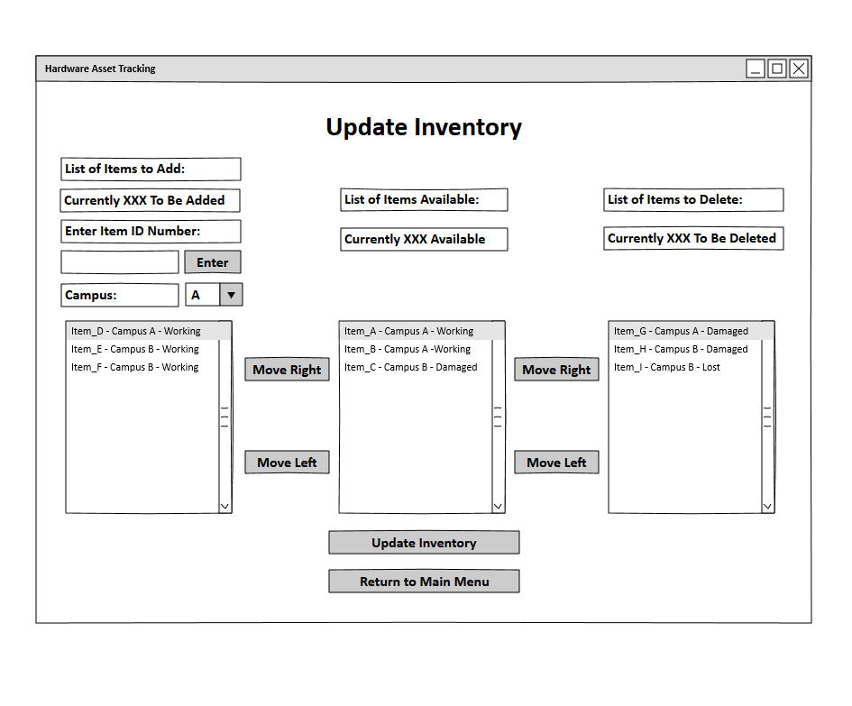

*Field/Data Elements*

|  |  |  |  |
| --- | --- | --- | --- |
| Field Name | Required | Field Type | Notes |
| Enter Item ID Number | - | Free Text | User inputs ID Number of item |
| Enter | - | Button |  |
| Campus | - | Drop Box | User chooses from a list of campus’ |
| Items to Add List | - | Scroll Box | Displays name of item, campus where item is store, and current condition of item |
| Available Inventory List | - | Scroll Box | Displays name of item, campus where item is stored, and current condition of item |
| Items to Delete List | - | Scroll Box | Displays name of item, campus where item is stored, and current condition of item |
| Move Right | - | Button | Move highlighted item from left scroll box to the right scroll box |
| Move Left | - | Button | Move highlighted item from right scroll box to the left scroll box |
| Update Inventory | - | Button | Stores new item inventory |
| Return to Main Menu | Yes | Button | User is redirected to Main Menu |

Selecting Update Inventory

* Update Inventory Page will display. This page allows the user to update the available inventory list.
* To add an Item to the Items to Add List, the user will need to:
  + Enter the Item ID number in the Enter Item ID Number field.
  + Press the Enter button.
  + Select the corresponding campus where the item will be stored in the Campus drop box field.
* Use the Move Left and Move Right buttons to move the desired items to the Available Inventory List in order to add items to the Available Inventory List or to the Items to Delete List.
* If the “Update Inventory” button is clicked, the Available Inventory List will be updated and the items in the Items to Add List and Items to Delete List will be deleted.
* If the “Return to Main Menu” button is clicked, the Main Menu Page will display.

Current List of Outstanding Issues

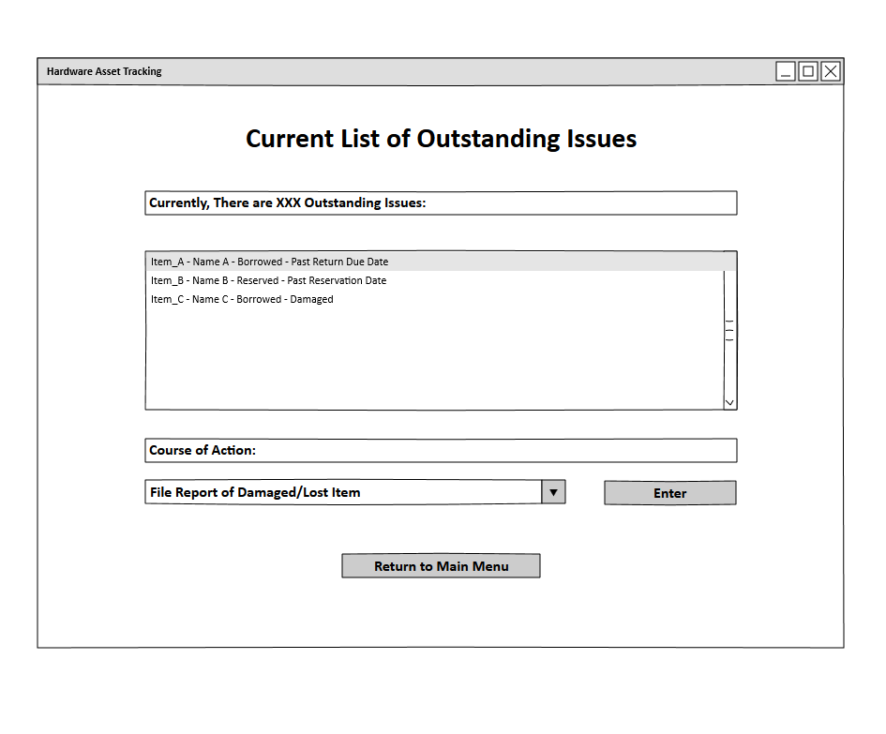

*Field/Data Elements*

|  |  |  |  |
| --- | --- | --- | --- |
| Field Name | Required | Field Type | Notes |
| Items Borrowed | - | Scroll Box | Displays name of borrower/reservation holder and a description of the outstanding issue |
| Course of Action Entry | Yes | Drop Box | Choices:   * File Report of Damaged/Lost Item * Clear Outstanding Issue |
| Enter | Yes | Button |  |
| Return to Main Menu | Yes | Button | User is redirected to Main Menu |

Selecting Current List of Outstanding Issues

* Current List of Outstanding Issues page displays. This page contains the number of known issues regarding borrowed items.
* The page displays the item, the client, whether it was borrowed or reserved, and the issue.
* After selecting the item simply by clicking, a course of action is required which ranges from:
* Filing Report of Damaged/Lost Item – Simply uploading a report detailing the issue.
* Clear Outstanding Issue – Simply removing the item from the list
* Clicking “Enter” button confirms your selection for the course of action.
* Clicking “Return to Main Menu” displays the Main Menu Page.

History of Borrowed/Reserved Items

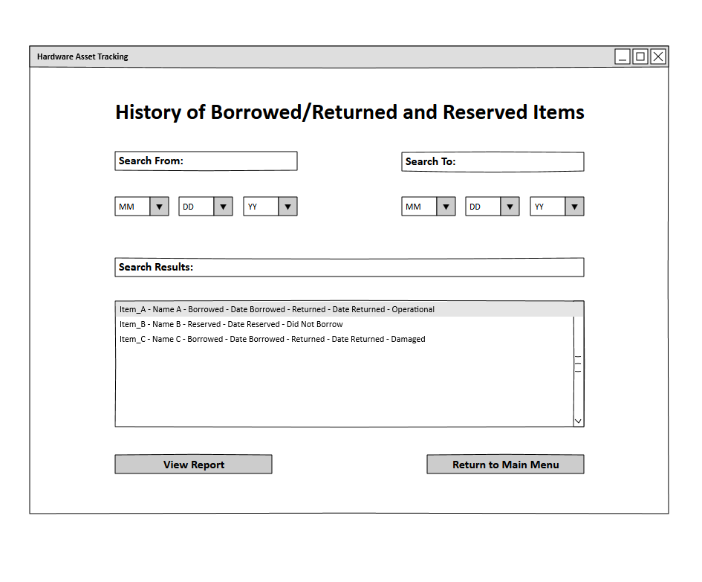

*Field/Data Elements*

|  |  |  |  |
| --- | --- | --- | --- |
| Field Name | Required | Field Type | Notes |
| MM/DD/YY | Yes | Drop Box | Select month, date, year |
| Items List | - | Scroll Box | Displays name of Person, type of action taken, and status of item |
| View Report | - | Button | Displays stored report (if exists) of highlighted section of Items List scroll box |
| Return to Main Menu | Yes | Button | User is redirected to Main Menu |

Selecting History of Borrow/Reserved Items

* History of Borrow/Returned and Reserved Items page displays.
* Date must be selected in the form of month, day, and year using the drop box method.
* In the Items list, the history of borrowed, reserved, and returned items is displayed from the dates that were initially chosen.
* If “View Report” button is clicked, the highlighted Item List’s stored report will be displayed.
* If “Return to Main Menu” is clicked then the Main Menu page displays.

Input Borrow Request

Entering Borrower Contact Information

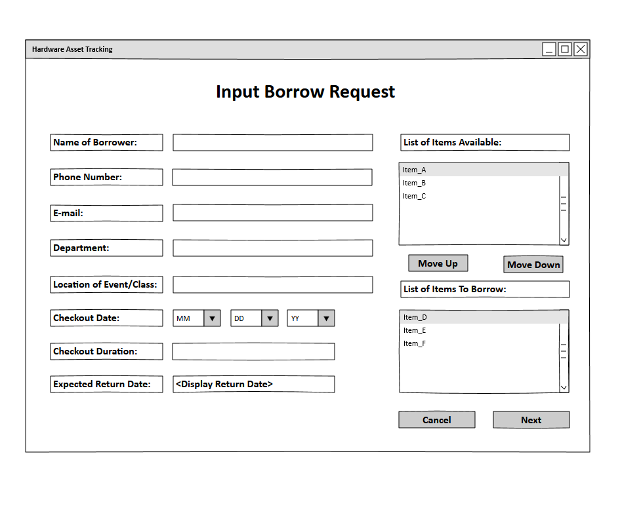

*Field/Data Elements*

|  |  |  |  |
| --- | --- | --- | --- |
| Field Name | Required | Field Type | Notes |
| Borrower Name | Yes | Free Text | Enter name of borrower |
| Phone Number | Yes | Free Text | Enter number of borrower |
| E-Mail | Yes | Free Text | Enter E-Mail of borrower |
| Department | - | Free Text | Enter Department borrower belongs to |
| Location of Event/Class | - | Free Text | Enter the event or class items are being used for |
| Checkout Date | - | Drop Box | Choose date when items are checked out |
| Checkout Duration | - | Free Text | Input expected duration for borrower |
| Expected Return Date | - | Free Text | Input expected return date of items |
| Items Available List | - | Scroll Box | Displays items available |
| Move Up | - | Button | Moves highlighted item in Items Available List Box and moves it to Borrowed Items List Box |
| Move Down | - | Button | Moves highlighted item in Borrowed Items List Box and moves it to Items Available List Box |
| Borrowed Items List | - | Scroll Box | Displays items being borrowed |
| Cancel | Yes | Button | User is redirected to Main Menu |
| Next | Yes | Button | Displays Input Scanning and Saving Request Form (Borrow) page |

Selecting Input Borrow Request

* Input Borrow Request Page Displays. This page allows user to enter client information and keep it on record.
* Borrower Name will be entered using free text.
* Using the “Move up” button moves available items to borrowed items.
* Using the “Move down” button moves borrowed items to available items.
* “Cancel button” displays Main Menu page.
* “Print Request” prints the form as well as items being borrowed and displays Input Scanning and Saving Request Form (Borrow) page.

Signature and Print Request

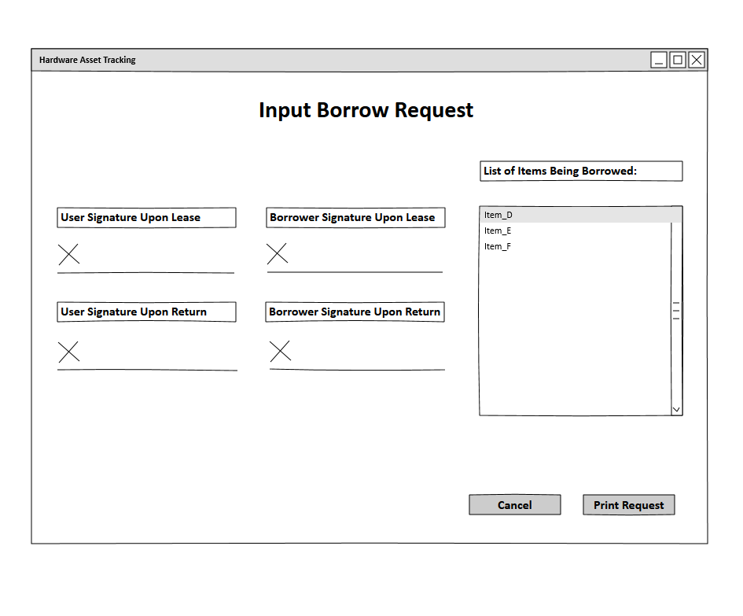

|  |  |  |  |
| --- | --- | --- | --- |
| Field Name | Required | Field Type | Notes |
| Cancel | Yes | Button | Returns to Main Menu page |
| Print Request | Yes | Button | Prints out form |

Input Scanning and Saving Request Form (Borrow)

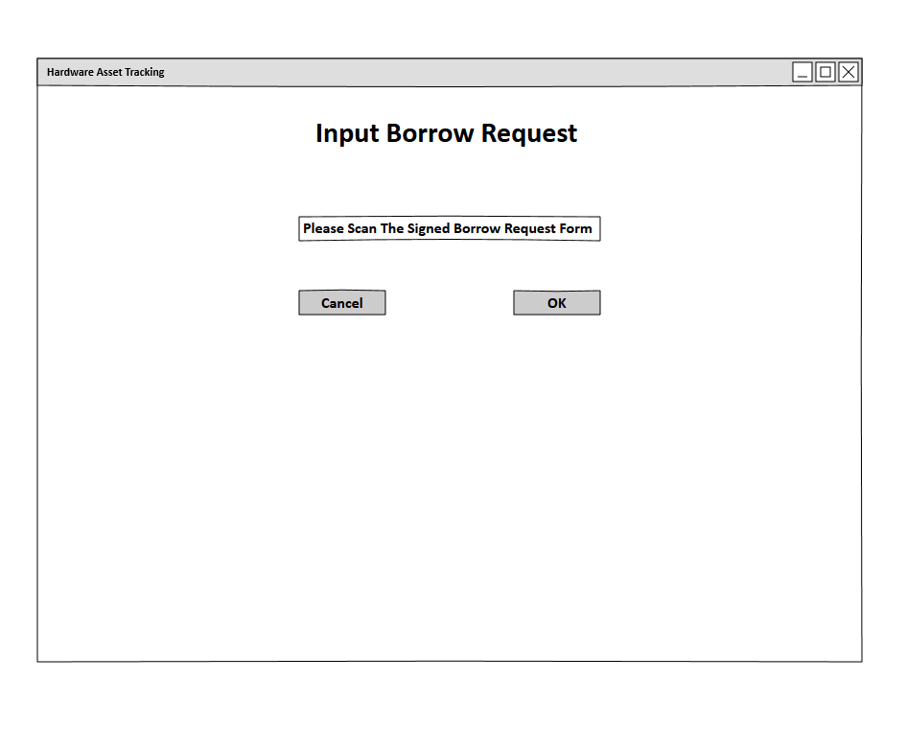

*Field/Data Elements*

|  |  |  |  |
| --- | --- | --- | --- |
| Cancel | Yes | Button | User is redirected to Main Menu |
| Ok | Yes | Button | Program checks if something has been scanned:   * Displays error message if failed * Redirects user to Main Menu page if successful |

* Completion of Input Borrow Request will display Input Scanning and Saving Request (Borrow) Form.
* Clicking “OK” button verifies whether document gas been scanned and saves it then displays Main Menu page.
* “Cancel” button displays Main Menu page.

Input Return Request

Searching Request Form

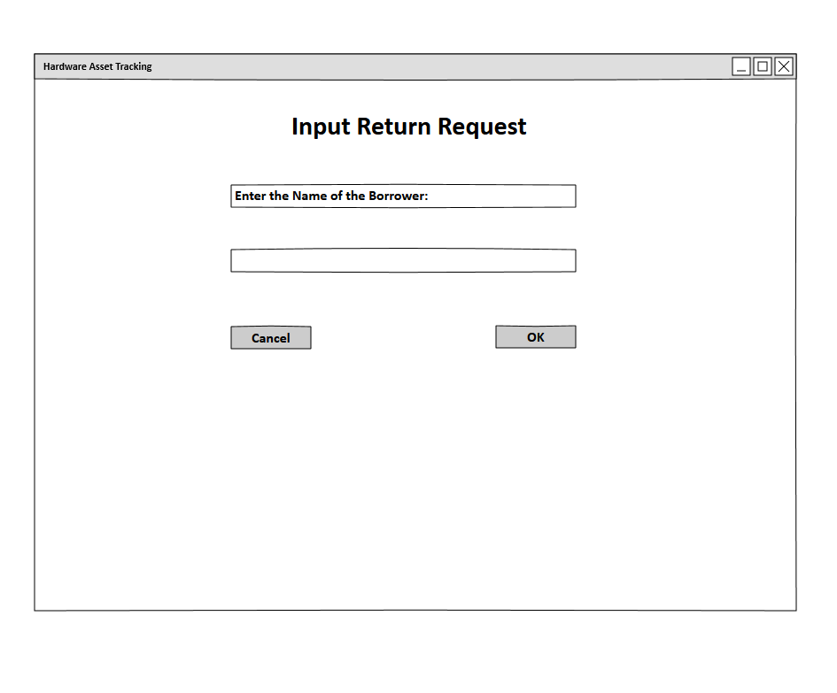

*Field/Data Elements*

|  |  |  |  |
| --- | --- | --- | --- |
| Borrower Name | Yes | Free Text | Enter name of borrower |
| Cancel | Yes | Button | User is redirected to Main Menu |
| Ok | Yes | Button | Program checks for borrower name:   * Displays error message if failed * Redirects user to Scanning and Saving Request Form (Return) if successful |

Selecting Input Return Request

* Input Return Request page displays. User enters name of borrower.
* “OK” button searches and verifies name and displays Scanning and Saving Request Form (Return) page.
* “Cancel” button displays Main Menu page.

Input Scanning and Saving Request Form (Return)

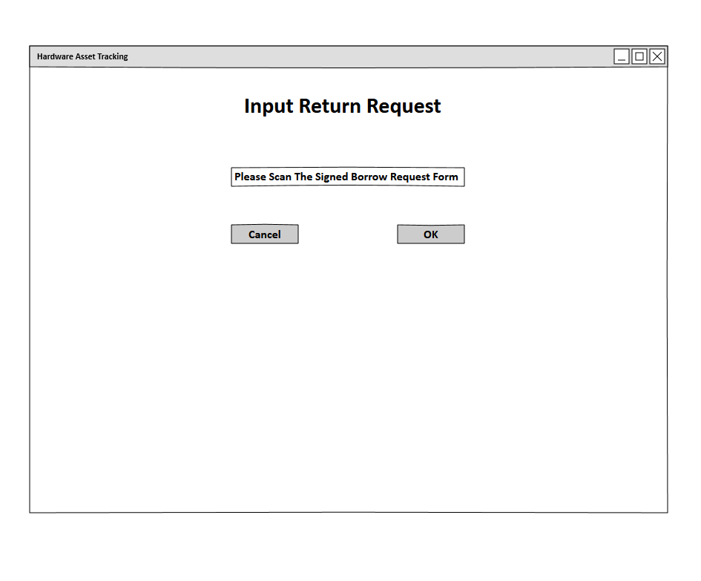

*Field/Data Elements*

|  |  |  |  |
| --- | --- | --- | --- |
| Cancel | Yes | Button | User is redirected to Main Menu |
| Ok | Yes | Button | Program checks if something has been scanned:   * Displays error message if failed * Redirects user to Main Menu page if successful |

* “OK” button checks and verifies if a document has been scanned then saves the document.
* “Cancel” button displays Main Menu page.

View/Change EnTeC Class Reserved Amount 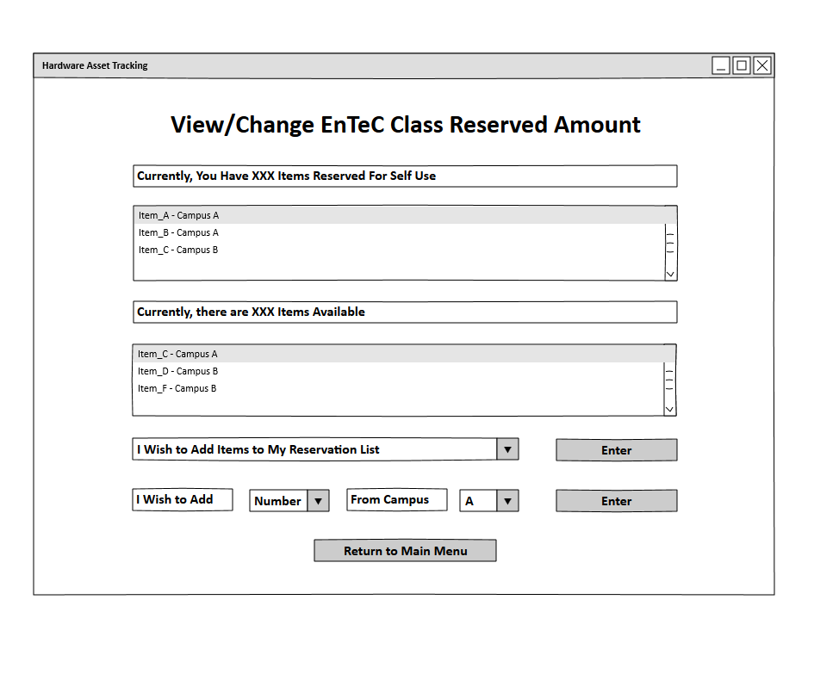

*Field/Data Elements*

|  |  |  |  |
| --- | --- | --- | --- |
| Field Name | Required | Field Type | Notes |
| User Reserved Items List | - | Scroll Box | Displays items reserved by the user and the campus location of those items |
| Available Items List | - | Scroll Box | Displays items available to reserve and the campus location of those items |
| Add/Remove Choice | - | Drop Box | Choices:   * I wish to add items * I wish to remove items |
| Number Choice | - | Drop Box | Select number to add/remove |
| Campus Choice | - | Drop Box | Select from which campus to reserve from |
| Enter | - | Button | Will display error if all of the drop boxes have not been selected by user, or if there is insufficient items available to reserve. |
| Return to Main Menu | Yes | Button | User is redirected to Main Menu |

Selecting Change Number for User Reservation

* Number of User-Reserved Items page displays.
* User reserved items are displayed per campus.
* Available items are displayed per campus.
* Add/Remove choice is chosen through a drop box.
* The amount added/removed is chosen through a drop box.
* Campus choice is chosen through a drop box.
* “Enter” button verifies information and carries out command.
* “Return to Main Menu” displays Main Menu page.